How to setup GPS on Raspberry Pi

Source: http://www.pridopia.co.uk/rs-pi-set-usb-gps.html

Setting up the USB Adapter

Once you plug the USB cable into the Pi, the adapter should show up as /dev/ttyUSB0 (though the '0' may be different if you have other ttyUSB adapters present).

You can see a list of all ttyUSB devices by entering the following into the console

sudo lsusb

Which should show you the USB adapter (Prolific PL2303), as follows:

Installing a GPS (gpsd)

The next step is installing some software on your Raspberry Pi that understands the serial data that your GPS module is providing via /dev/ttyUSB0.

Thankfully other people have already done all the hard work for you of properly parsing the raw GPS data, and we can use (amongst other options) a nice little package named 'gpsd', which essentially acts as a layer between your applications and the actual GPS hardware, gracefully handling parsing errors, and providing a common, well-defined interfaces to any GPS module.

To install gpsd, simply run the following commands from the console:

sudo apt-get install gpsd gpsd-clients python-gps
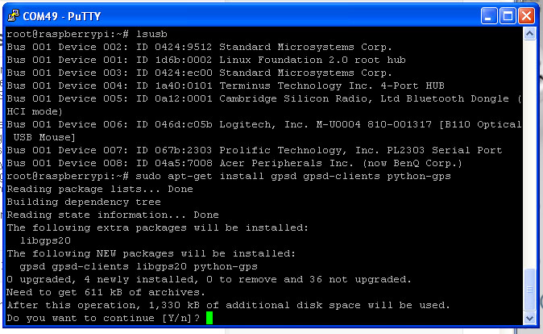

sudo gpsd /dev/ttyUSB0 -F /var/run/gpsd.sock

which will point the gps daemon to our GPS device on the USB to TTY

adapter cable (simply substitute '/dev/ttyUSB0' for another destination if required).

Viewing whats in the sky & your location
After a few seconds, gpsd should open up the proper socket and if the GPS is locked we should be able to get some data from the GPS module.

To test this, we can use the following command:

cgps -s

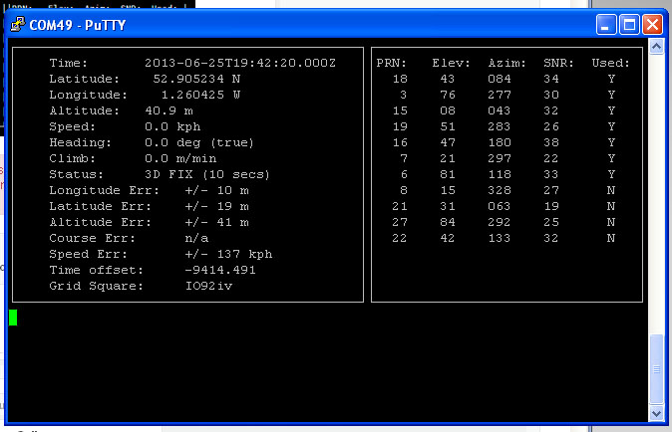

If you have a fix, you'll see something like the following information in the terminal window:

If you have any problems and cgps always displays 'NO FIX' under status and then aborts after a few seconds, you may need to restart the gpsd service. You can do that via the following commands:

sudo killall gpsd

sudo gpsd /dev/ttyUSB0 -F /var/run/gpsd.sock

cgps -s
Viewing GPS under X-Windows

xgps

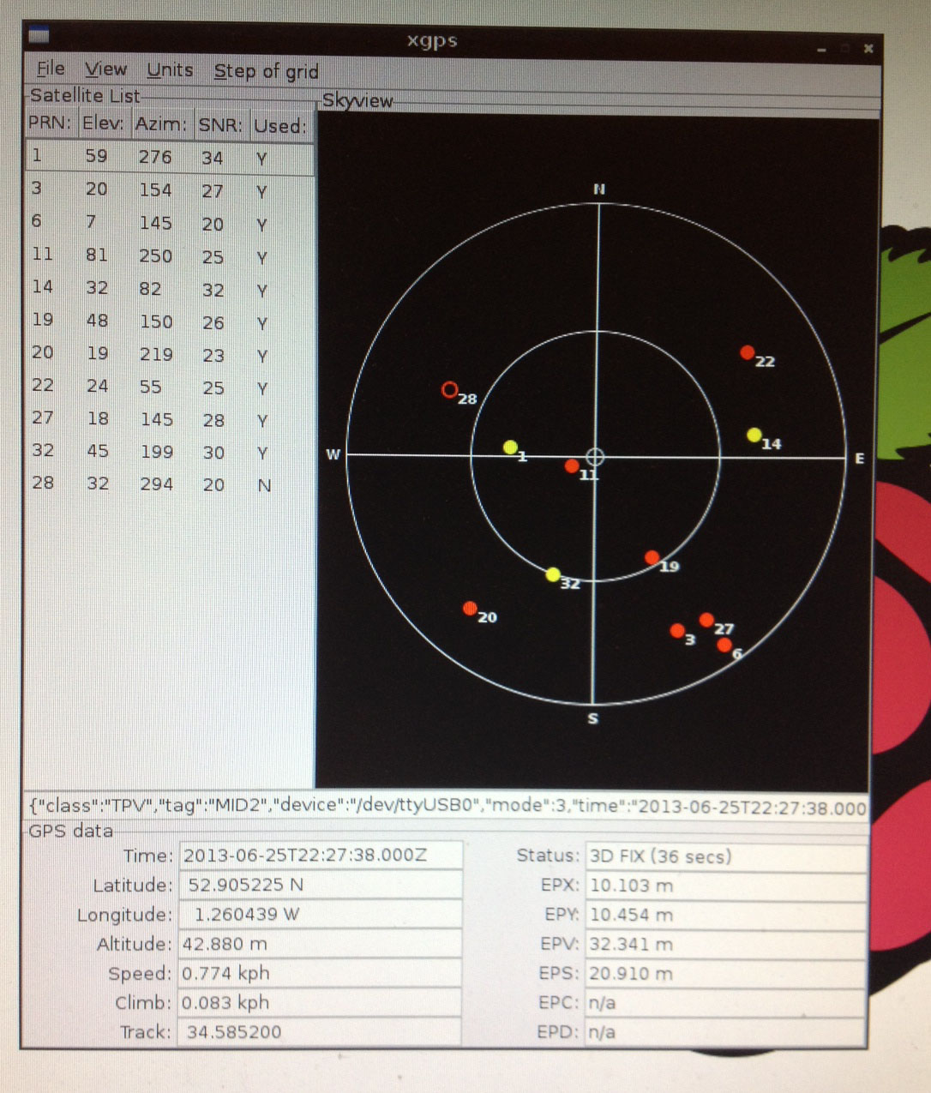

GPSD Client software information

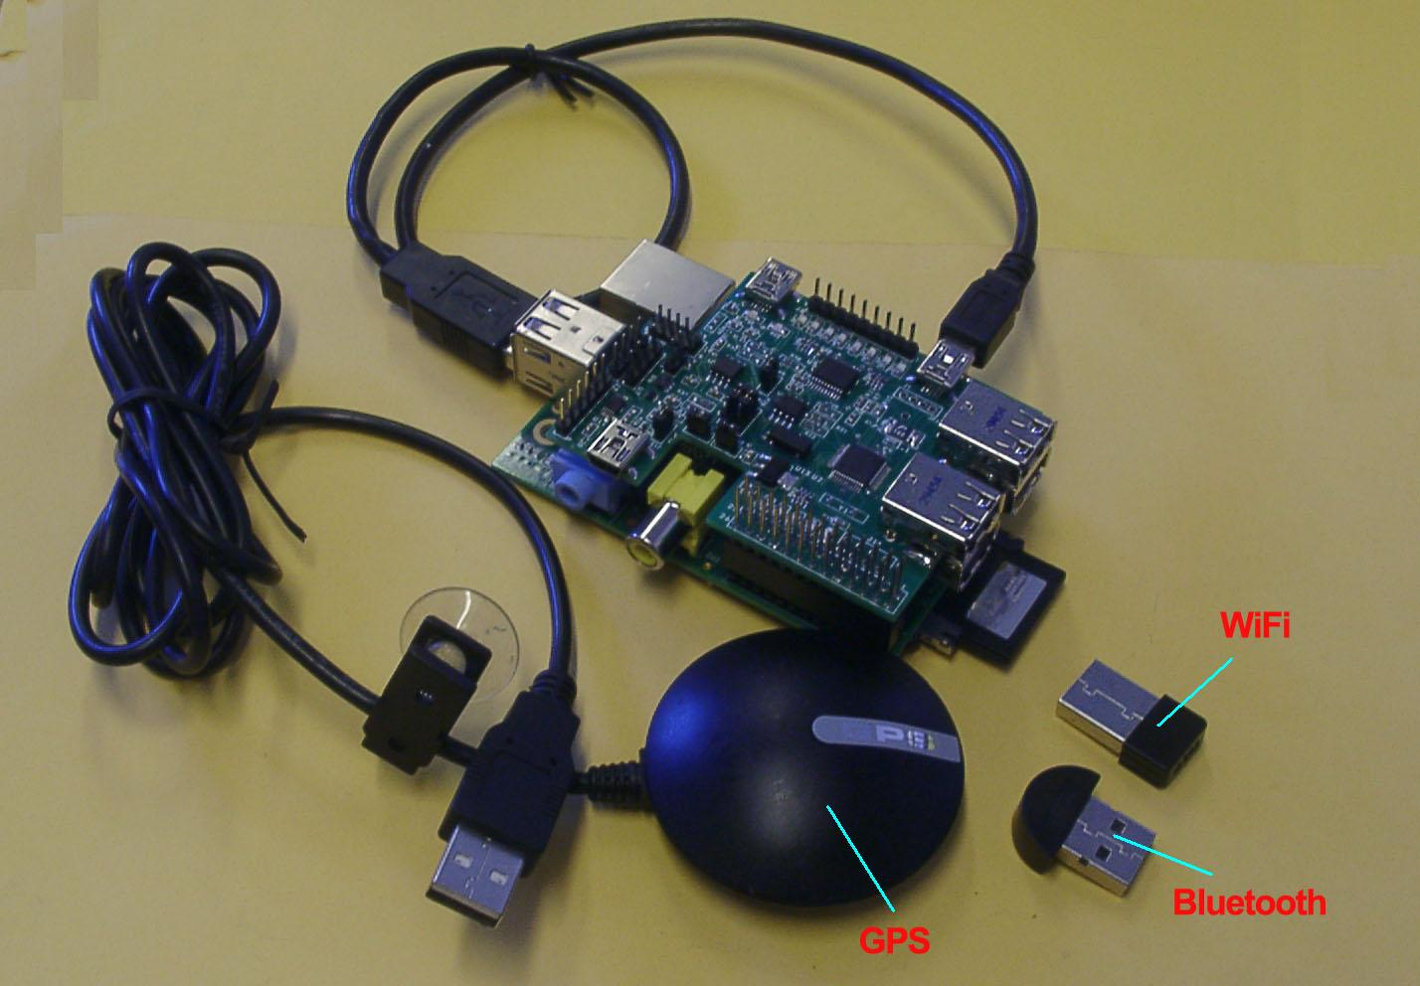

Test USB GPS, USB WiFi Dongle & USB Bluetooth Dongle with our USB 4 Port hub board



